# ASSIGNMENT NO-13

* **Problem Statement:- create a workmail for your organization.**
* **Steps:**-
* **Organisation Creation**

1. In the search tab, type amazon workmail. In amazon workmail, click “**Create Organisation”.**

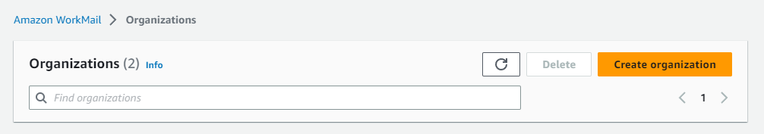

1. In organization settings, click “**Free test domain”**. In Alias type name of your organisation(ex-mckv1234).

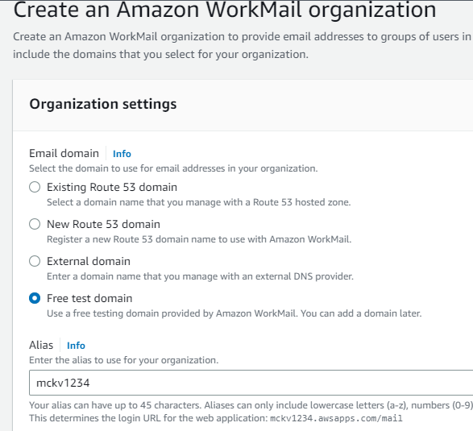

1. In organization, click **Users** in the left side window. In Users, click “**create user**”.

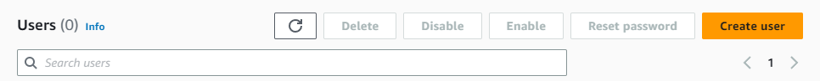

1. Type user name,first name,last name and give password and click create user.

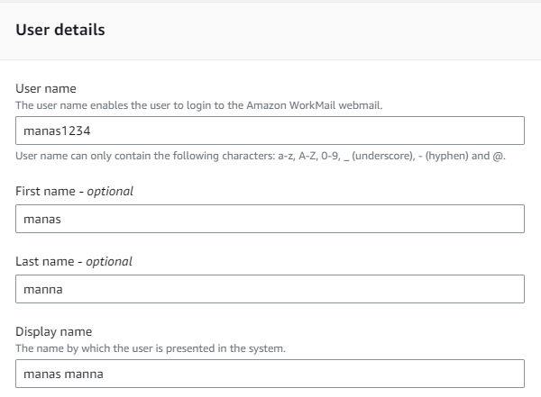

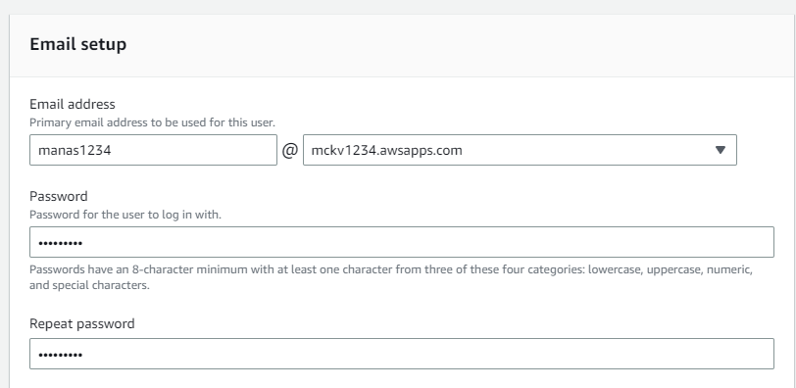

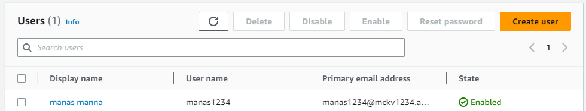

1. Now, go to organization and click **Amazon workmail web Application.**

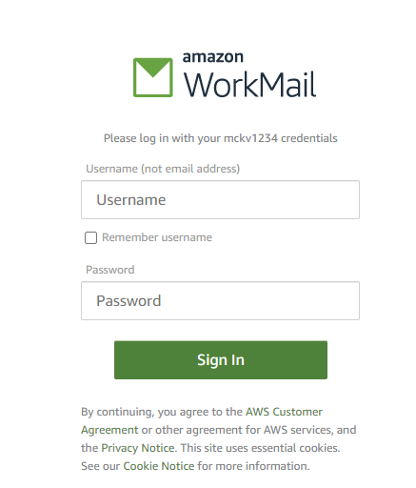

1. Give username and password and it will open.

